Perspective Inspection Eye Care

Kapili, Joey Graccil

Cebu Institute of

Technology - University

N. Bacalso Avenue,

Cebu City, 6000

+63085848791

graccikapili1@gmail.com

Fernandez, Gianfranco

Cebu Institute of

Technology - University

N. Bacalso Avenue,

Cebu City, 6000  
Telephone number

E-mail

3rd Author

3rd author's affiliation  
1st line of address  
2nd line of address  
Telephone number, incl. country code

3rd E-mail

**ABSTRACT**

In this paper, we describe the formatting guidelines for ACM SIG Proceedings.

**CCS Concepts**

• **General and reference → Document types, Surveys, and overviews • General and reference → Cross-computing tools and techniques** **• Computer systems organization → Real-time systems → Real-time operating systems • Software and its engineering → Software creation and management → Designing software • Software and its engineering → Software creation and management → Software verification and validation • Information systems → Information storage systems → Record storage systems**

**Keywords**

Ophthalmologist; eye specialist; appointment; doctor

# INTRODUCTION

Internet are knowledgeable nowadays, many people even from 70’s, 80’s uses internet. It is a modern software to connect people anytime and anywhere. Internet can be useful to almost anything in today’s generation. Specially appointments where you can access the internet and set your schedules. Our project called Spection is a website for Ophthalmologist to accommodate patients or inquiries. This website is design to connect eye patients and doctors online. There is no need for taking a leave in your daily work just to book your schedule. Everyone can be accommodated from children to adults.

Our eyes are one of the key assets giving us motivations and hope to perform daily challenges of living. It is important to have

When having a health clinic, it is important to accommodate as many patients as possible. It is important to give them ahead notice of what there experiencing and knowledge about their symptoms. It is important for the doctor to communicate to them as much as possible for the possible immediate cure to avoid losing the patients vision.

Here in Cebu City, Philippines most of the people here works in the city with no time to have check their health. Which means they are vulnerable to damaging their body. Kids, Teens, Adults can already experience eye problems with no time to be checked by professionals. Spection will provide a convenient appointment reservation and diagnostic test for the patients to avoid hassle on taking time to go physically to the clinic. On the other hand, Spection will store data and implement a graphical trend for the health records which gives the doctors knowledge of the health records of their patients.

The graphical trend will serve as an overview of the diagnosis and diseases experienced by the patients. Gives the doctor’s knowledge and awareness.

## 1.1 REVIEW OF RELATED SOFTWARE

## The following applications have similar features to the proposed project. Each application are reviewed based on the proposed project Spection.

* + 1. **Eduardo Besser, MD**

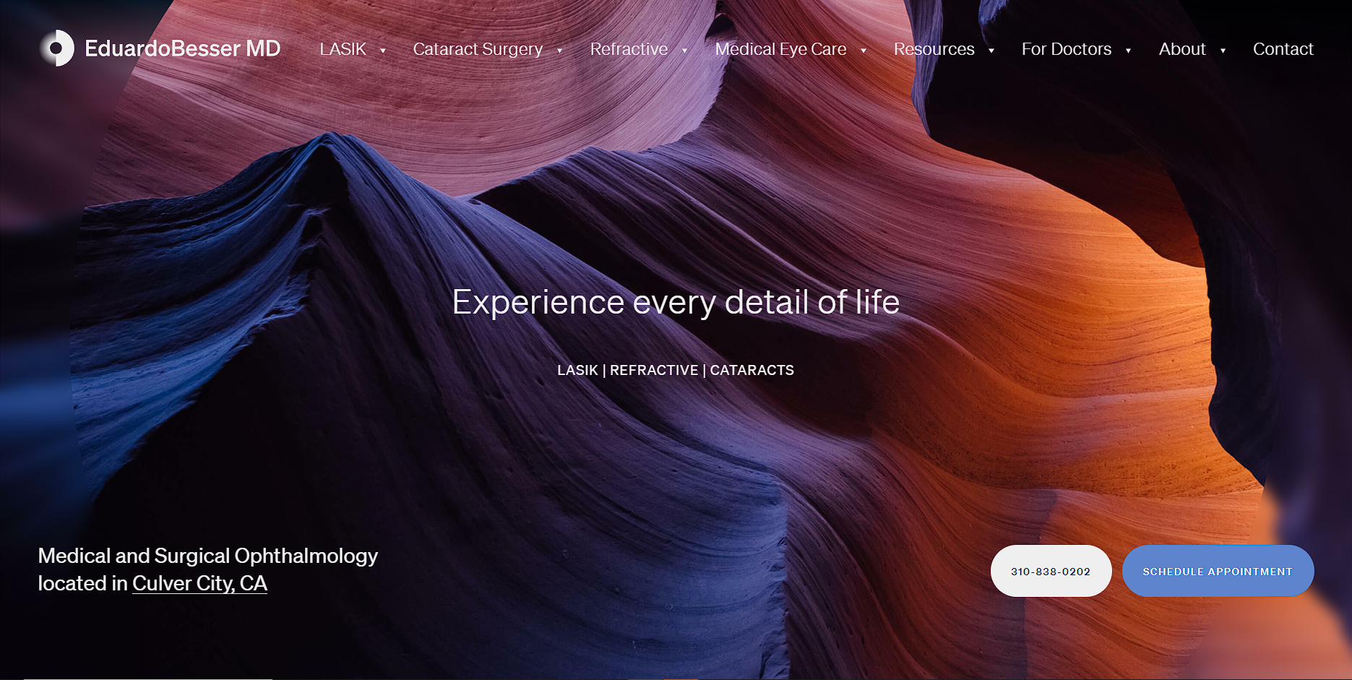

**Figure 1: Eduardo Besser Main Web Page**

The Eduardo Besser, MD website offers an intuitive menu design. It includes information that ophthalmology patients frequently look for on a website. Patients can quickly find details about the office’s services, forms, and staff.

**1.1.2 Advanced Vision Care**

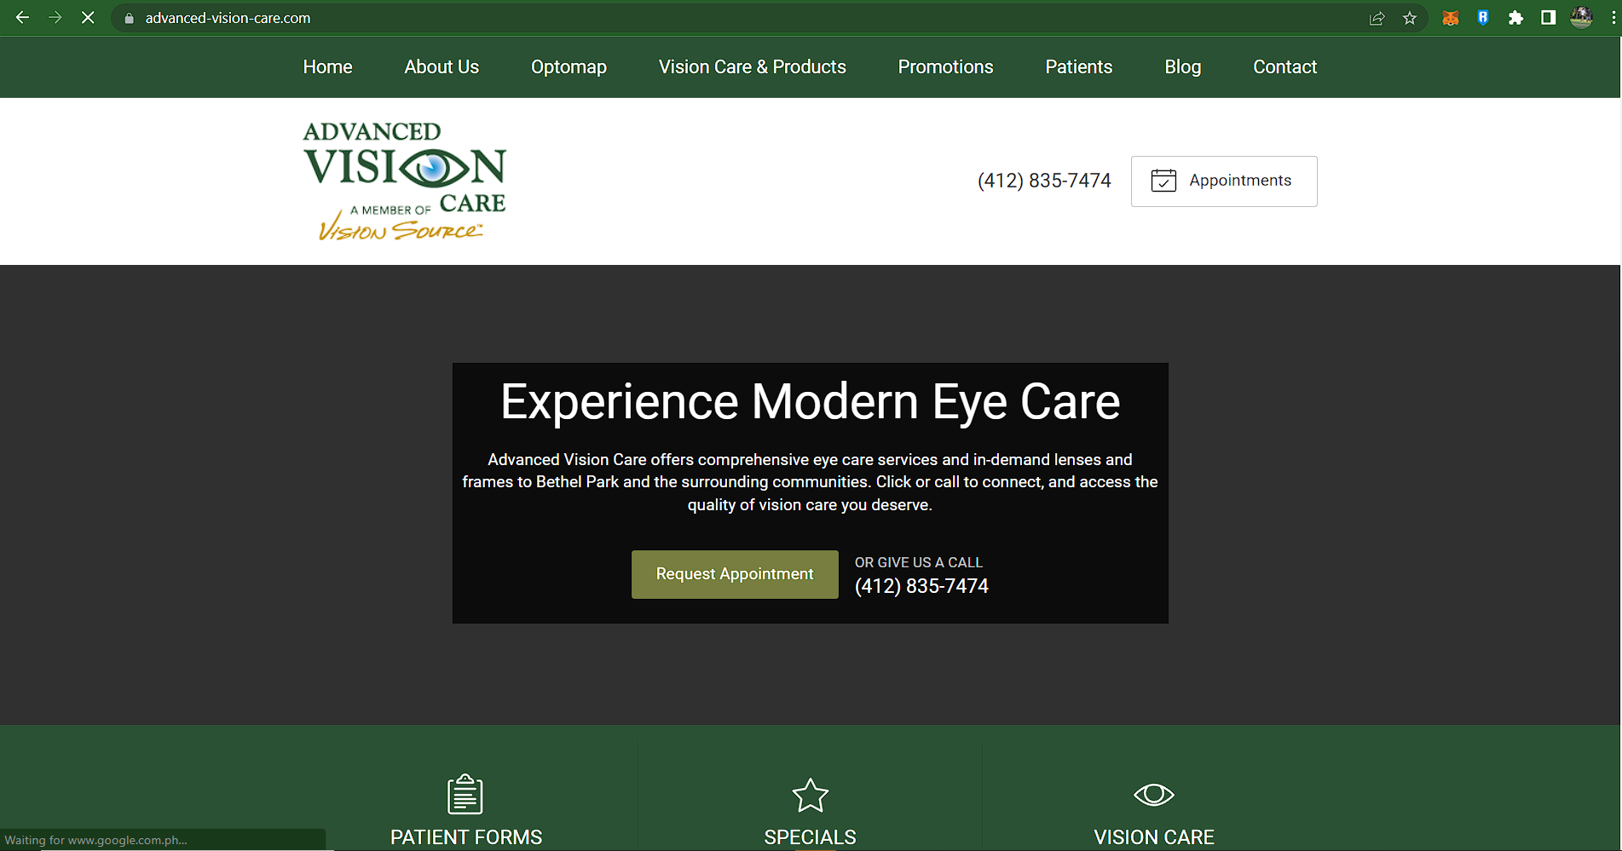

**Figure 2: Advanced Vision Care Main Web Page**

Advanced Vision Care’s website includes important messaging about business hours at the top of the page. Other essential features include user-friendly contact forms, an appointment calendar, social media buttons and an updated blog. The site loads quickly on mobile and desktop devices.

* + 1. **Benjamin Eye Institute**

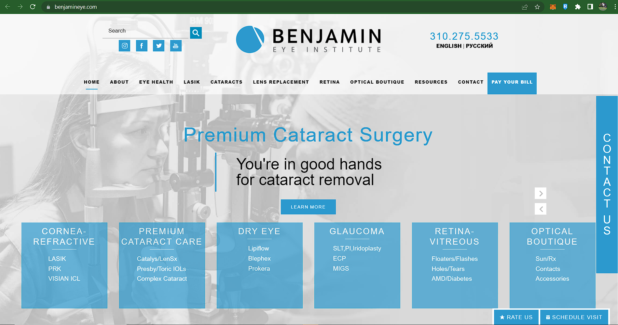

**Figure 3: Benjamin Eye Institute Main Web Page**

The Benjamin Eye Institute site is easy to navigate. Patients can learn more about the eye center by clicking the hamburger menu icon. The menu provides quick access to information about services, eye health and a blog. Patient resources on the website include instructions, maintenance tips, contact lens information and forms.

* + 1. **American Eye Institute**

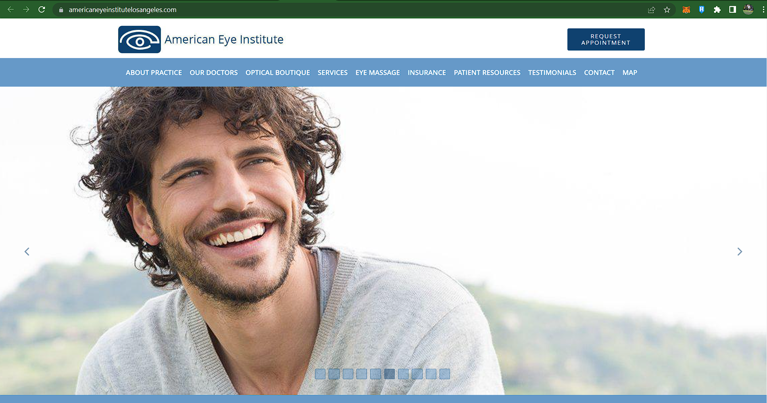

**Figure 4: American Eye Institute Main Web Page**

The American Eye Institute’s website provides a few ways for patients to request appointments. They can schedule a virtual visit online or request an in-person appointment by phone. The site includes Yelp reviews from patients. These reviews build trust with site visitors. This site includes information about American Eye Institute’s on-site eyeglasses boutique.

* + 1. **Maloney-Shamie Vision Institute**

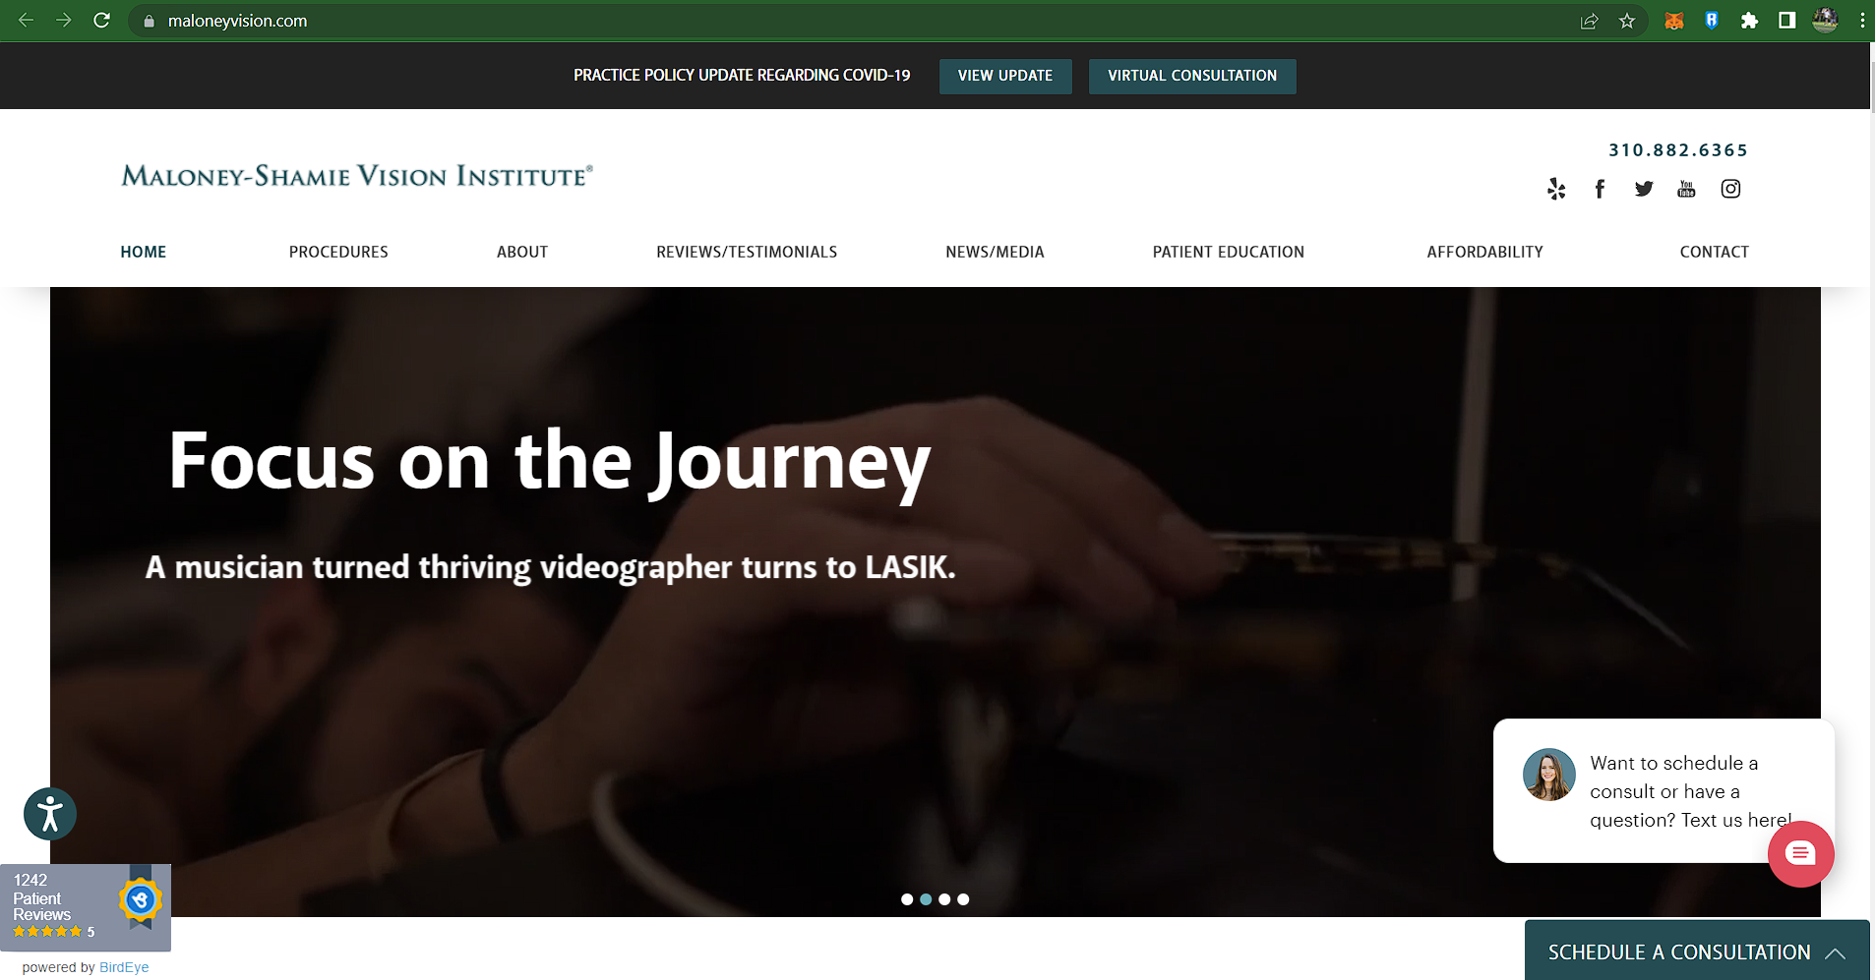

**Figure 5: Maloney-Shamie Vision Institute Main Web Page**

The Maloney-Shamie Vision Institute’s website has a responsive design. The homepage header features videos and lively pictures. It includes a list of news and media outlets that have featured this eye center. Patients can book a virtual consultation online or chat with a representative during business hours. Online patient education information includes online books and educational videos.

* + 1. **Acuity Eye Group**

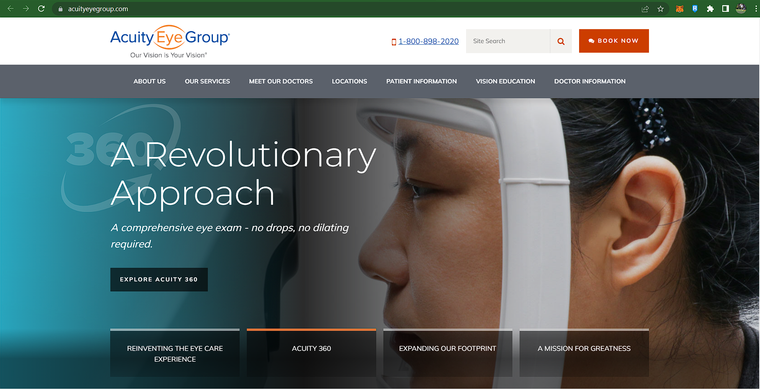

**Figure 6: Acuity Eye Group Main Web Page**

Acuity Eye Group offers a streamlined website design. Its menu includes information about locations, the doctors, resources and services. Patients can explore the services before they schedule an appointment. The mobile site offers streamlined navigation in a user-friendly format.

* + 1. **OAV Ophthalmology**

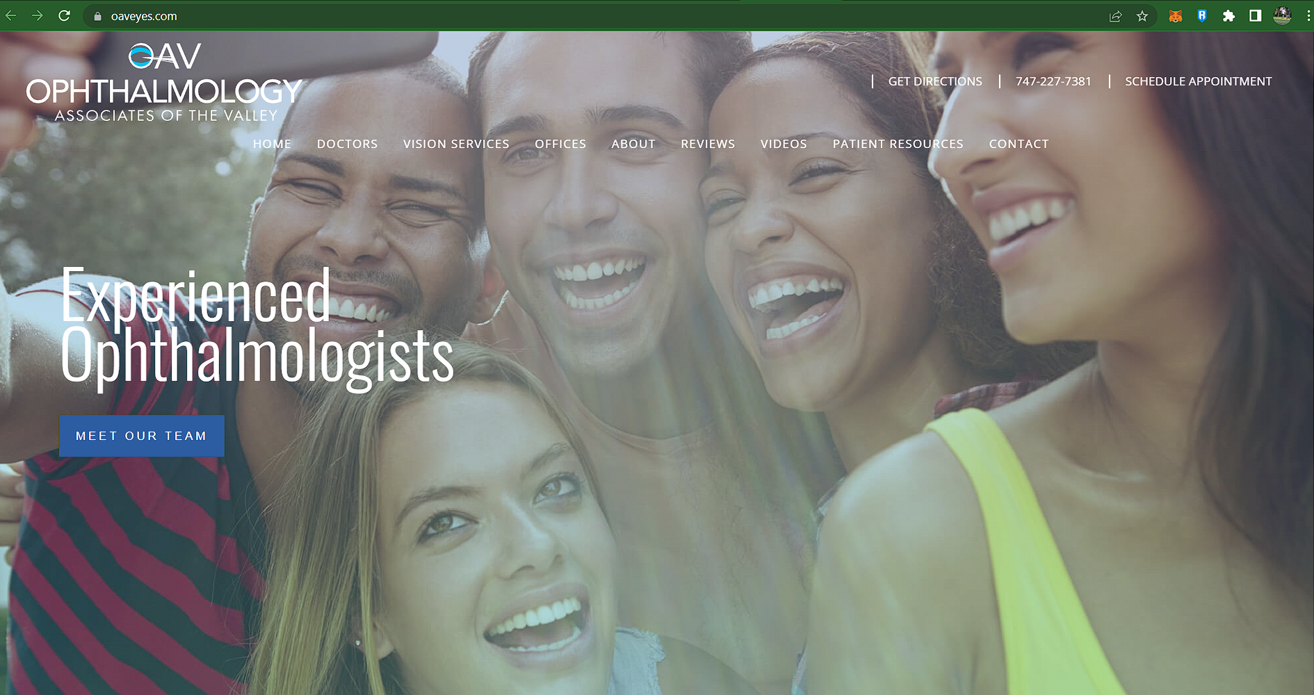**Figure 7: OAV Ophthalmology Main Web Page**

OAV Ophthalmology has a website with a simple design and color scheme. The homepage provides information about the services, practice and facilities. Other key website features include patient reviews, videos and office locations.

* + 1. **Kagan Institute Vision and Aesthetics**

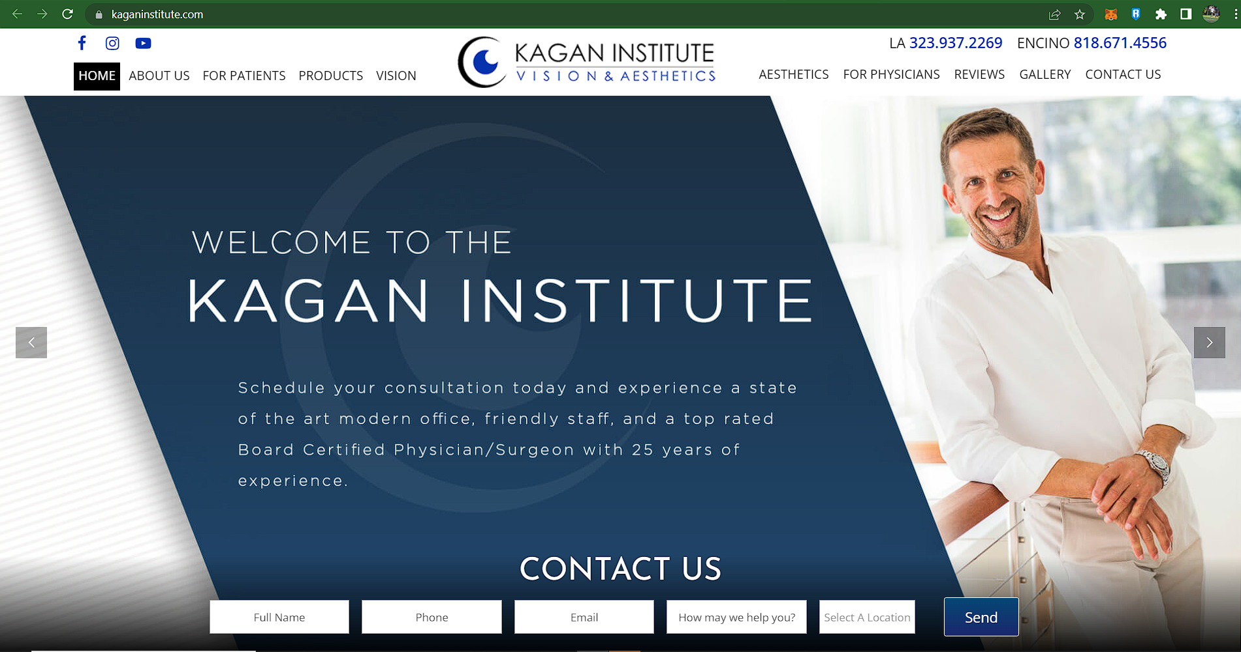

**Figure 8: Kagan Institute Vision and Aesthetics Main Web Page**

The Kagan Institute Vision and Aesthetics website offers a few ways for patients to contact the office on the homepage. A contact form is located directly beneath the header. Key website features include social media icons, information about services and a gallery of before/after photos. On this site, patients can learn about dry eye, vision correction, cataracts, eye disease, migraine/headache treatments and eyelid rejuvenation.

* + 1. **LOH Ophthalmology**

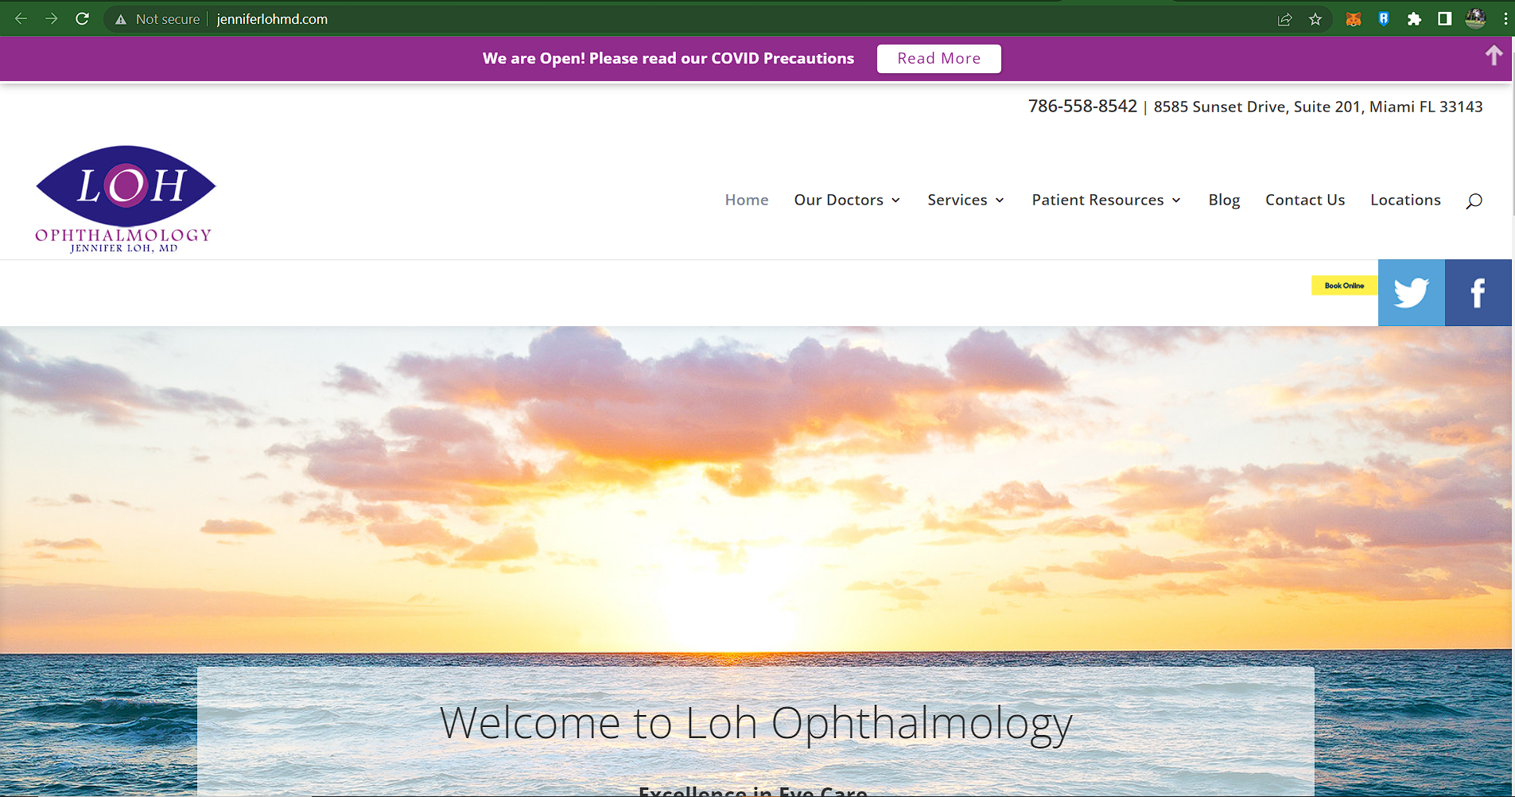

**Figure 9: LOH Ophthalmology Main Web Page**

The Loh Ophthalmology Associates website includes an online booking system. By clicking a button, patients can securely book an appointment without calling the office. Patient resources include an online cataract IOL self-test, a media center and patient forms. The location page includes a Google Map that shows the office location.

* + 1. **Eye Doctors of South Florida**

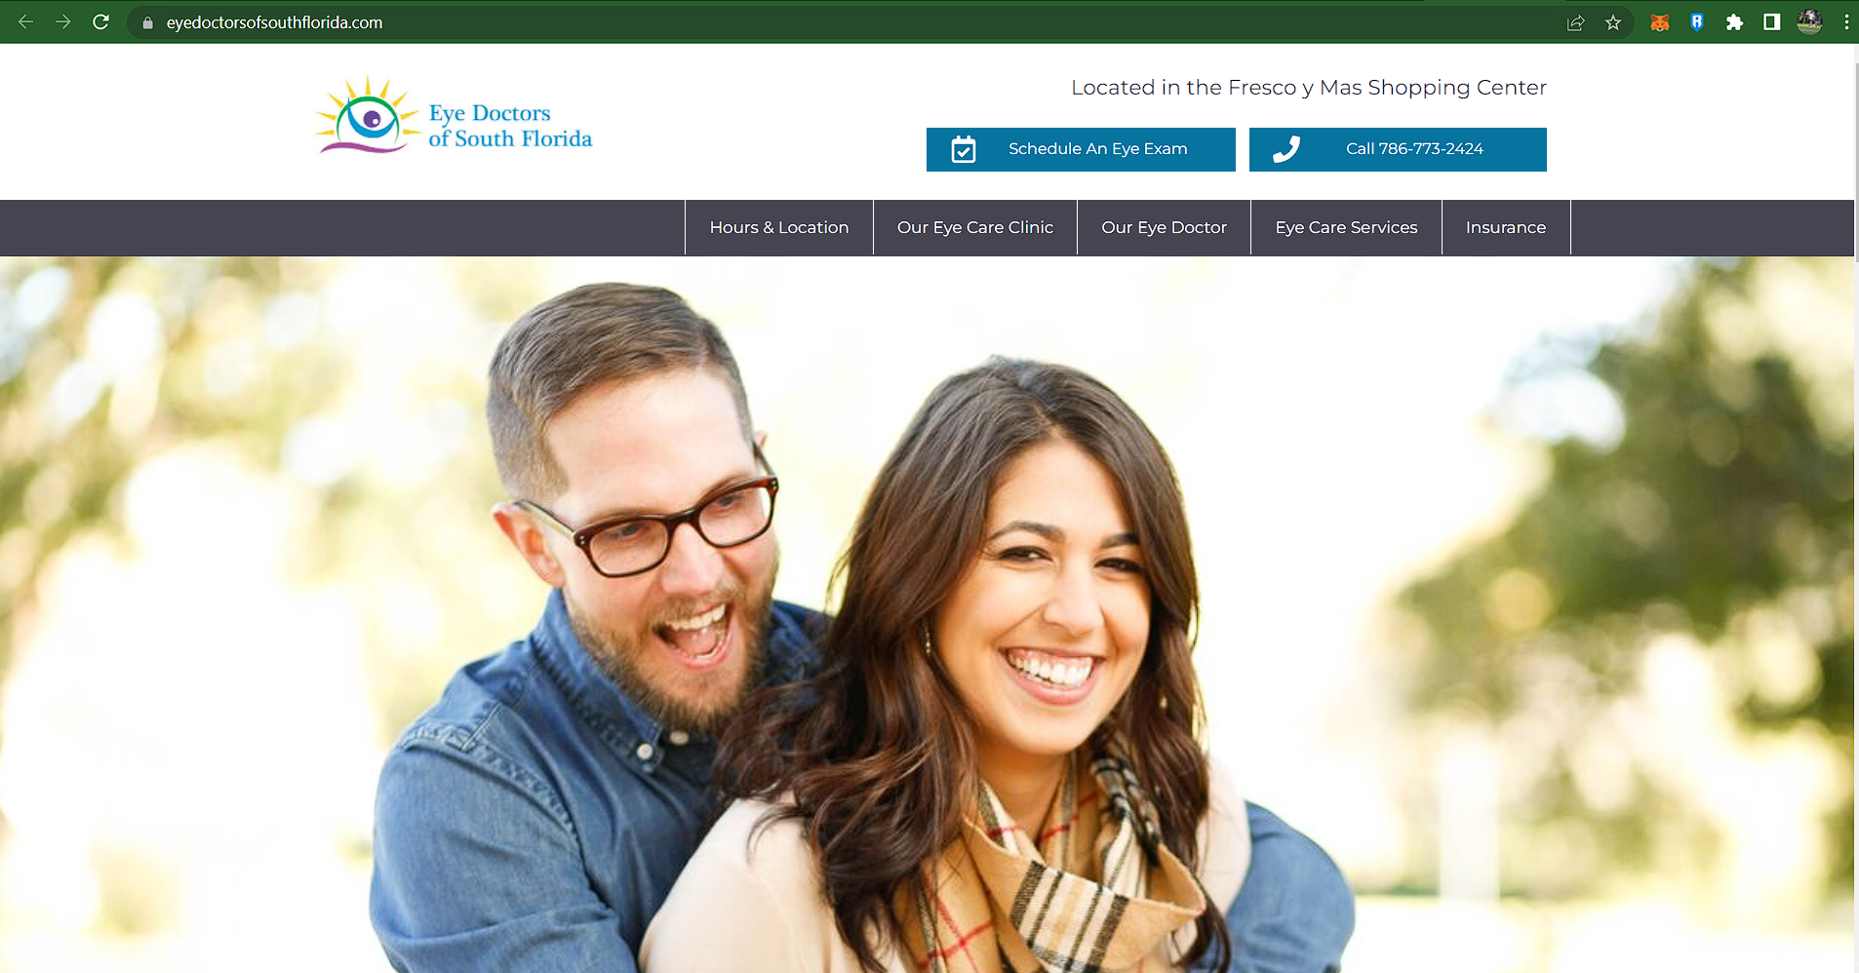

**Figure 10: Eye Doctors of South Florida Main Web Page**

The Eye Doctors of South Florida website offers a clean design with stunning photos. The menu bar includes tabs to access insurance information, eye care services and hours/locations. Patients can schedule an eye exam on the website. Other user-friendly features include contact forms throughout the website and a Google Map.

## Page Numbering, Headers and Footers

Do not include headers, footers or page numbers in your submission. These will be added when the publications are assembled.

# 1.1.11 MATRIX

The table shows the comparisons among other competitors in different features**.**

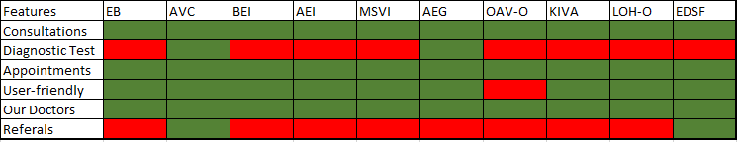

# REFERENCES

[1] <https://www.eduardobessermd.com/>

[2] <https://advanced-vision-care.com/>

[3] <https://www.benjamineye.com/>

[4] <https://www.americaneyeinstitutelosangeles.com/>

[5] <https://www.maloneyvision.com/>

[6] <https://www.acuityeyegroup.com/>

[7] <https://oaveyes.com/>

[8] <https://kaganinstitute.com/>

[9] <http://www.jenniferlohmd.com/>

[10] <https://www.eyedoctorsofsouthflorida.com/>